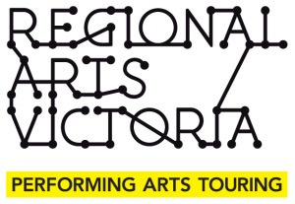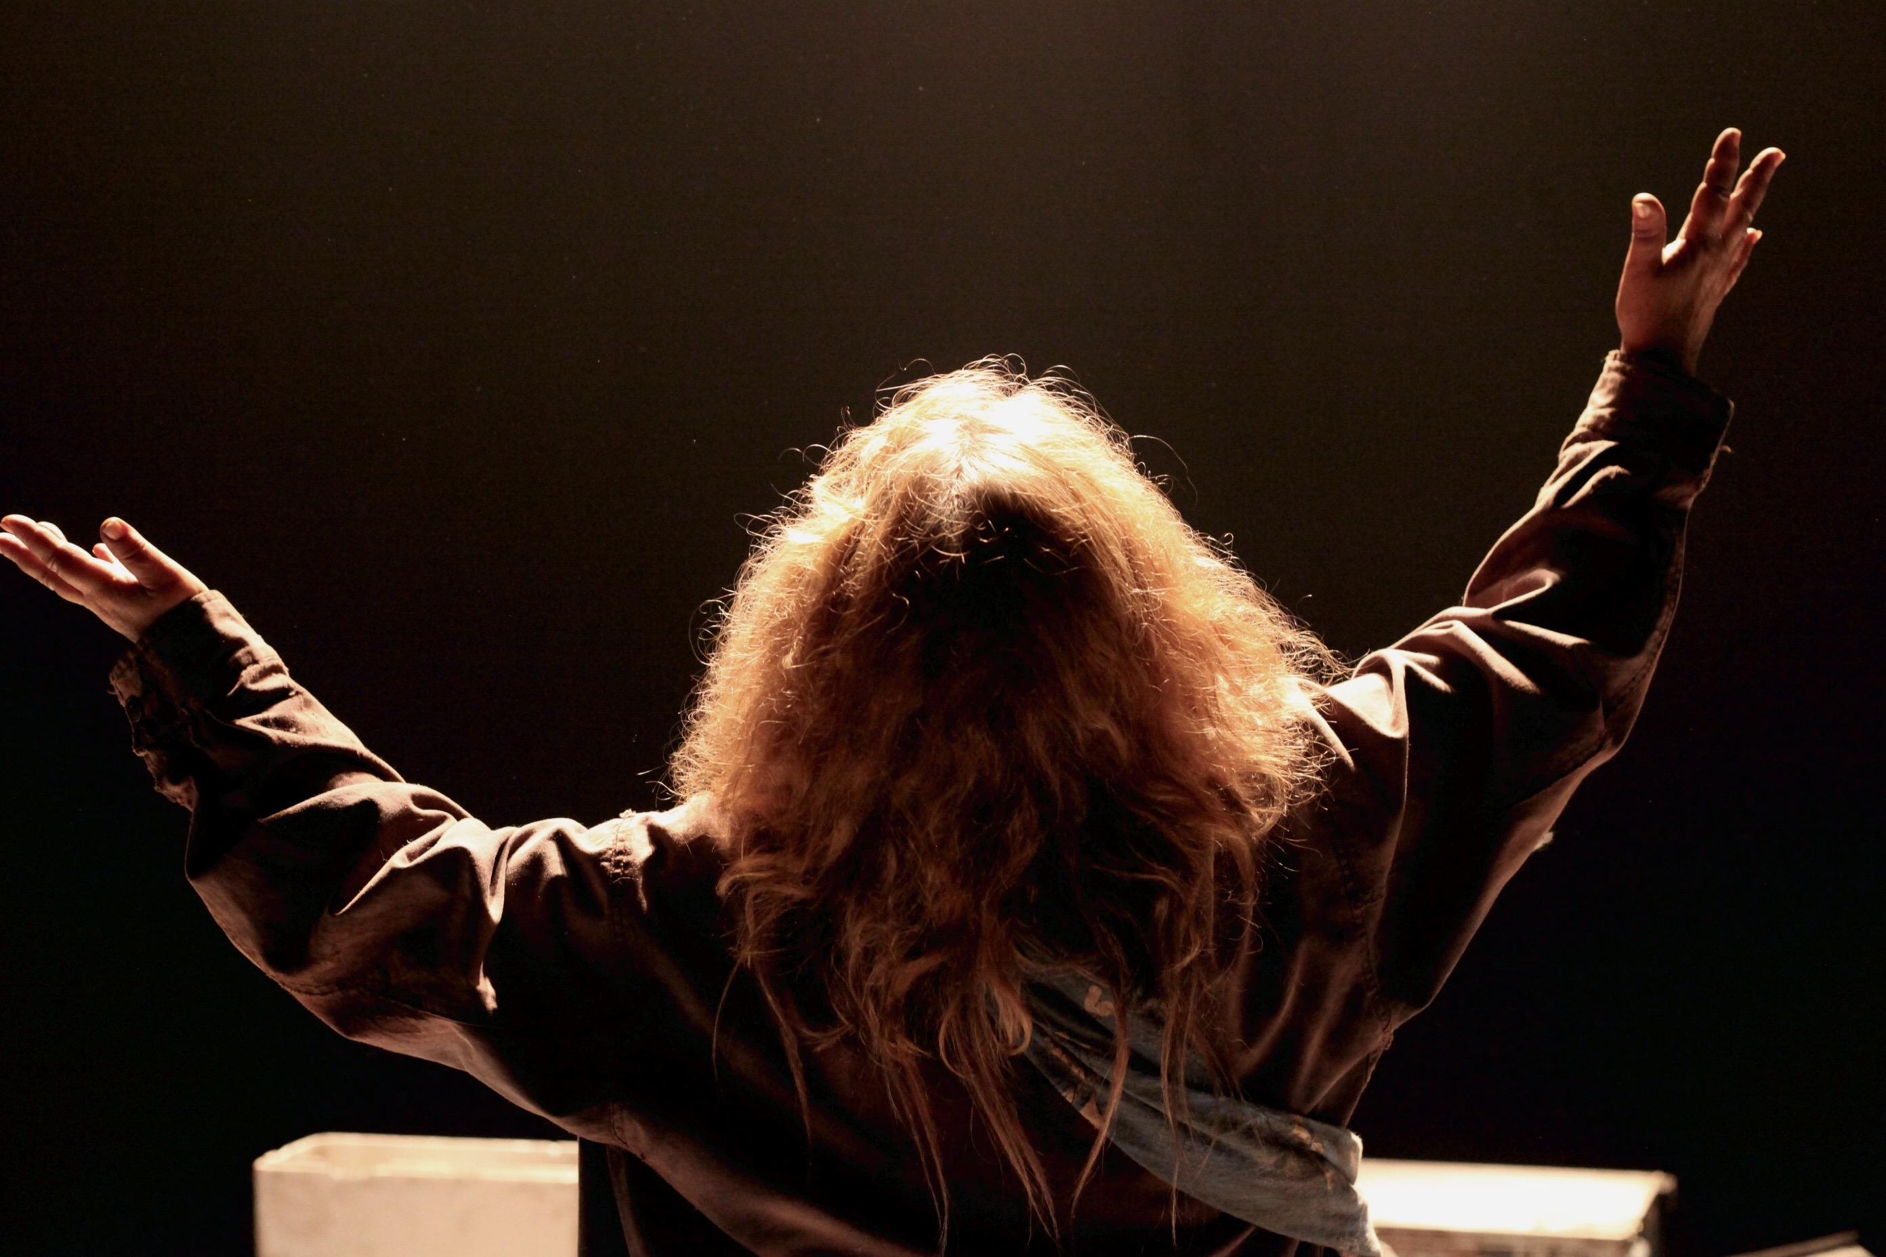

2016 Tour

If Theatre & Regional Arts Victoria presents

Noni Hazlehurst in  
MOTHER

MOTHER

Written by Daniel Keene

Directed by Matt Scholten

mattscholten.com/mother  
Follow us on Twitter @MotherThePlay

This production is dedicated to Irene Troy & Alida Scholten

Matt Scholten, Artistic Director If Theatre

[mattjscholten@gmail.com](mailto:mattjscholten@gmail.com)

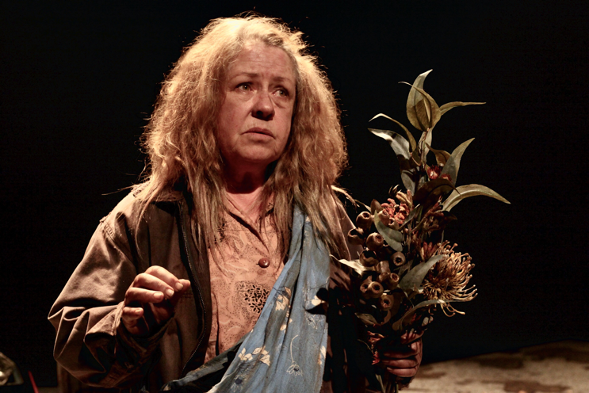

*"All goes unanswered, love is unanswered, out of the dark*

*A tongue without speech, a hand without touch, a crude potter’s thumb,*

*Grooves us a moment, the Esperanto of sense*

*Jabbers our language, all that we hold in common.*

*Yet wings make grubs articulate, cocoons are spun for shattering,*

*And though you keep your hand over my mouth,*

*I will keep on singing, dry cicada under the spring."*

Dorothy Hewett from *Unanswered Love Letter*

Performer Noni Hazlehurst

Director Matt Scholten

Set, Costume & Props Kat Chan

Lighting Design Tom Willis

Sound Design Darius Kedros

Stage & Tour Manager Ainsley Kerr

Producers If Theatre & Regional Arts Victoria

Thank you to Shayne Greenman for his love and support always, Kane Forbes, Dale Packard, Ella Bucovaz & Rosie Dwyer from Regional Arts Victoria, Michaela Nutt, Sue Muggleton, Matt Emond, Bryony Nainby, Tony Smith & all at Gasworks Arts Park, the venues who gave their time and energy to the tour, especially the Reference Groups.

Ainsley, thanks for your dedication, energy and passion, Darius, thanks for making the incredible sounds and the silences, Tom, thank you for your light on and off stage and dearest Kat for almost ten years of love, art and misheard conversations. Daniel, it has always been my honour to direct your work, it has made me a better artist. Noni, there are no words, or maybe just some small ones: love, thanks, faith, friends and truth. Let's keep playing.

I would like to thank Peta Hanrahan who gave me my first opportunity to direct Daniel's work back in 2008 at The Dog Theatre.

I would also like to thank all of the artists who have worked with me on the plays of Daniel Keene: Matthew Molony, Anthony Winnick, Katherine Branch, Brendan McCallum, Majid Shokor, Bruce Myles, Jan Friedl, Danielle Carter, Harli Ames, Lisa Mibus, Geoff Chan, Lok Tan, Ben Keene, Roger Oakley, Zoe Ellerton Ashley, Brad Williams, Susanne Kean, Kate Shearer, Terry Yeboah, Katy Warner, Halcyon McLeod, Tim Wotherspoon and Rosie Collins & Amy Bagshaw for steering the fleet.

Matt Scholten

More thanks

Paul Zabrowarny, cellist

Bec Taylor, Hairstylist

Serena Ryan for rehearsal photography

Megan Williams and Selene Bateman at Auspicious Arts

Karralyka staff for 2016 remount

Claire, Rachel & Stefania at Currency Press